**Title: Gemini Decode – Multilanguage Document Extraction by Gemini Pro**

1. **Project Overview**

GeminiDecode is a cutting-edge document extraction tool developed to address the challenges of handling multilingual documents. The project leverages the capabilities of advanced artificial intelligence models and Python-based libraries to process, extract, and analyze documents in a wide range of languages. GeminiDecode simplifies the task of extracting meaningful data from complex documents like PDFs, enabling users to interact with the extracted information through an intuitive web interface powered by Streamlit.

The project’s core functionality revolves around its ability to handle different languages and present extracted content in a user-friendly manner. It utilizes Google's generative AI to improve the accuracy and contextual understanding of the extracted text, allowing for deeper analysis and enhanced usability.

1. **Technical Architecture**

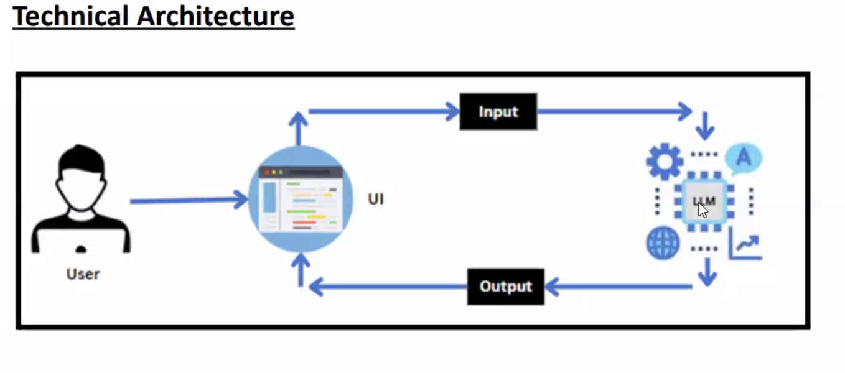

1. **Key Features**

• **Multilanguage Document Extraction**: GeminiDecode is designed to extract text from documents written in multiple languages, offering high flexibility for users who work with international content. It detects languages automatically and applies the right models for accurate extraction and representation.

• **Interactive Web Interface**: Built using **Streamlit**, the tool offers a streamlined, interactive user experience. Users can upload documents via the web interface, and view the extracted content in real time.

• **PDF and Document Handling**: Through **PyPDF2**, GeminiDecode can manage and extract content from PDFs, including metadata, textual data, and other relevant elements of the document structure.

• **AI-powered Content Analysis**: The integration of **Google Generative AI** allows for intelligent processing of the extracted text, including summarization, translation, keyword extraction, and contextual analysis. This improves the depth of the output, allowing users to work with information that is not just extracted, but also meaningfully interpreted.

• **Document Vectorization and Search**: Utilizing **ChromaDB** and **FAISS**, the tool vectorizes the extracted content, making it searchable by semantic similarity. This allows users to search for relevant information within their documents, even if they do not know the exact terms.

1. **Technologies Used**

The following key technologies are employed in the project:

* **Streamlit**: Provides an easy-to-use framework for building custom web applications. It allows the tool to be deployed as a web service where users can upload documents and view the processed results.
* **Google Generative AI**: Powers the extraction and processing of multilingual content. It uses models trained on vast datasets to provide insights and contextual understanding that would be difficult with conventional tools.
* **LangChain**: Manages the interaction between different AI models. It provides a flexible framework to integrate language models and improve their interaction, allowing for more robust extraction and analysis.
* **PyPDF2**: A Python library used for reading and processing PDF files. It ensures that all relevant text and metadata are extracted from uploaded PDFs, which are a common format for business documents and research papers.
* **ChromaDB**: A database system used for managing and storing vector embeddings of text. It allows for fast, scalable similarity searches across large sets of document vectors, supporting tasks like information retrieval and recommendation.
* **FAISS (Facebook AI Similarity Search)**: Used for efficient and fast similarity searches across the vectorized document content. It allows for near real-time search, even across large datasets.
* **Pillow**: A Python Imaging Library (PIL) fork used for image processing tasks, in case documents include embedded images that need to be handled.

1. **Installation and Setup**

To get started with GeminiDecode, follow these steps:

* **Install Required Dependencies**: Install the dependencies using the requirements.txt file. This file lists all the Python libraries needed for the application to function correctly. The installation can be done by running:

pip install -r requirements.txt

Key dependencies from requirements.txt include:

* **Streamlit**: For the web application interface.
* **Google Generative AI**: For advanced AI functionalities.
* **LangChain**: For model orchestration and natural language processing.
* **PyPDF2**: For handling and extracting content from PDFs.
* **ChromaDB** and **FAISS**: For document similarity search and vectorization.
* **Pillow**: For image-related tasks

1. **Set Up Environment Variables**

A .env file should be created with the appropriate environment variables. For example, you’ll need to set your Google API key like so:

GOOGLE_API_KEY=<your_google_api_key>

1. **Run the Application**

Once everything is set up, you can launch the web interface by running:

streamlit run app.py

1. **File Structure**

* **app.py**: The primary application file where all the logic for document upload, extraction, and analysis takes place. This file contains code for handling user interactions, processing the uploaded documents, and displaying the results on the Streamlit interface.
* **requirements.txt**: This file lists all the necessary Python packages required to run the project. Installing these dependencies ensures that all the necessary libraries are in place​(requirements).
* **.env**: Stores environment-specific variables like API keys. This is crucial for external integrations like Google Generative AI.

1. **How GeminiDecode Works**

* **User Interaction**: Users interact with GeminiDecode through a simple Streamlit web interface. Here, they can upload their documents, which are then processed by the system.
* **Document Processing**: Once the document is uploaded, **PyPDF2** extracts the text (or metadata) from PDFs. For other formats, different handlers can be added in the future to expand the range of file types that GeminiDecode supports.
* **AI-based Analysis**: The extracted content is then passed to Google Generative AI via **LangChain**, which handles translation, summarization, and keyword extraction. The AI models enable the tool to understand the context and semantics of the document content, making the output more meaningful.
* **Vectorization and Search**: After processing, the content is vectorized using **ChromaDB** and **FAISS**, allowing users to search for similar content within the document. This is particularly useful when working with large sets of documents or complex documents with many sections.
* **Output Representation**: The results are displayed in the Streamlit interface, allowing users to view, search, and interact with the extracted content. Users can perform keyword searches, view summaries, and explore document insights easily.

1. **Use Case Example**

Let’s consider a typical use case where a user uploads a legal document in multiple languages. Here’s what GeminiDecode does:

* **Step 1**: The user uploads the document through the Streamlit UI.
* **Step 2**: GeminiDecode detects the languages in the document and extracts the text.
* **Step 3**: The AI-powered analysis runs, summarizing the document in the user’s preferred language. If required, it translates specific sections.
* **Step 4**: The document is vectorized, allowing the user to search for relevant legal terms or clauses within the document.
* **Step 5**: The processed output, including translations, summaries, and relevant sections, is displayed for user interaction.

1. **Conclusion**

GeminiDecode combines the latest advances in natural language processing, AI, and web development to create a powerful tool for multilingual document extraction and analysis. Its ability to process diverse languages and provide real-time feedback to users makes it highly suitable for professionals who work with complex, large-scale documents across different languages. The integration of AI-driven analysis and interactive search features allows for both high precision and ease of use in document handling.